|  |  |
| --- | --- |
| COACHING MANAGEMENT SYSTEM |  |
|  |  |
|  | AJAY PRATAP KANDARIMINI PROJECT REPORT |
|  | ROLL NO 62 SEC DB. TECH CSE 2016599 |



**MINI PROJECT REPORT**

Name: AJAY PRATAP KANDARI

Section: D

Class Roll No: 62

University Roll NO: 2016599

Topic: COACHING

MANAGEMENT SYSTEM

|  |  |  |  |
| --- | --- | --- | --- |
|  |  |  |  |
|  | INTRODUCTIONTechnology has been a huge part in shaping the today’s world. With the more advancements in technology and in the field of Computer Sciences people are shifting their lifestyle from traditional to a more digitalized form. Today even a small institution and even a small retail shop owner uses tech. in form of smartphones and applications to improve productivity and level of their lifestyles. | |  |
|  | In this project I have developed a web application called **Coaching Management System** which helps a particular coaching institute to manage the details of the students and faculties in a particular academic session. The system has two User login system. One for the students to view their details and with limited editing options.  The admin has the access to add, delete, and change the necessary details of the student in a particular academic session. Also, admin can see details of the faculties. |  |  |

|  |  |  |  |
| --- | --- | --- | --- |
|  |  |  |  |
|  | TOOLSUSED | **Front End Development**  **1.Html:**  HTML stands for Hypertext Markup Language and is used to structure a web page.  **2.CSS:**  Cascading Style Sheets is a style sheet language which is used to style the elements written in html. It is basically used to design the web pages written in html.  **3.JAVA-SCRIPT**  *JavaScript, often abbreviated JS, is a programming language that is used to add interactive behavior to web pages*. |  |
|  |  | |  |

|  |  |  |
| --- | --- | --- |
|  | Back-End Development |  |
| **1.php**  Php stands for recursive hypertext preprocessor is a scripting language which is used to design back end. It is embedded in html and is used to design the dynamic web pages. It’s basically a server- side scripting language.  **2.MySql**  MySql is a database management system. It is used to organize, store, update, access and manage the data.  **3.sql**  Sql stand for structured query language and is used to update, manage, insert, delete the data into database. |
|  |

|  |  |  |  |
| --- | --- | --- | --- |
|  |  |  |  |
|  | TOOLSUSED | **Developmental Tools**  **1.Visual Studio Code**  A cross platform IDE. All the front end and development is developed in this particular IDE  **2.phpMyAdmin**  A software used to manage the database created.  **3.XAMPP**  *XAMPP is used to provide the Apache local server to host the web application*.  **4.Chrome Development Tools**  To further style the web application. |  |
|  |  | |  |

**Modules:**

|  |  |  |  |
| --- | --- | --- | --- |
|  | Home-PageHome Page contains two login buttons. ADMIN can login to Admin Dashboard with admin login button. While student can login to student Dashboard with student login button.  The user is asked to enter the username and password to enter further into application. | |  |
|  |  |  |  |

|  |  |  |  |
| --- | --- | --- | --- |
|  |  |  |  |
|  | Working of the ApplicationThe user need to type the correct username and password to enter either to admin or student page. ADMIN MODULE: | |  |
|  | 1.After the logged in the admin is redirected to admin dashboard.  2.Search Student: With this button the admin can see the details of the student.  3.Edit Student: With this button the admin can edit the details of the student.  4.Add Student: The admin can the new record of the student in a particular academic session.  5.Delete Student: The admin can delete the record of the student in a particular academic session by entering its roll no.  6.Show Teachers: The admin can see the details of the faculties with this button. |  |  |

|  |  |  |  |
| --- | --- | --- | --- |
|  |  |  |  |
|  | Admin Dashboard ADMIN CAN ADD DELETE AND EDIT THE DETAILS OF THE STUDENT IN A PARTICULAR SESSION. HE CAN ALSO SEE THE DETAILS OF THE FACULTIES. | |  |
|  |  |  |  |

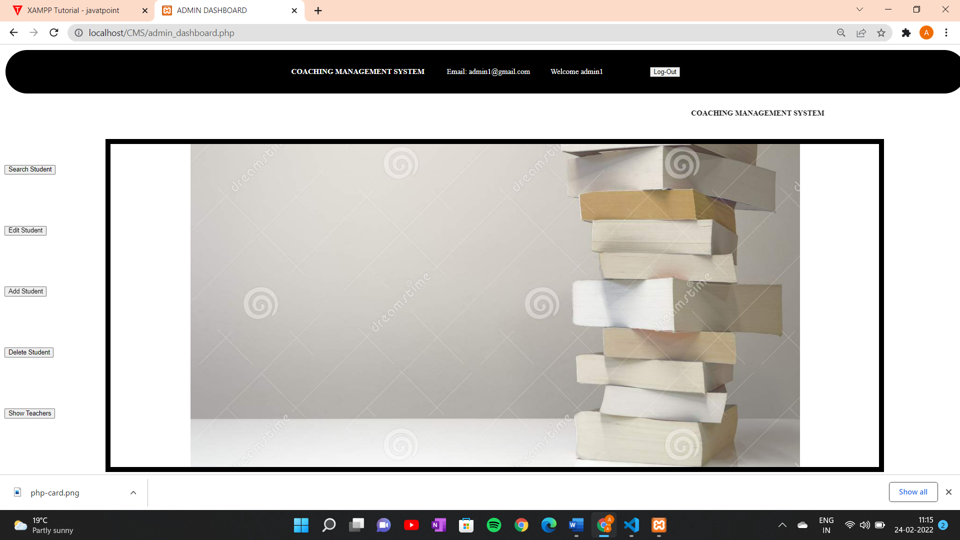

|  |  |  |  |
| --- | --- | --- | --- |
|  | **Search Student** The admin can search the student by clicking search student button and by entering the roll no of the student. | |  |
|  |  |  |  |

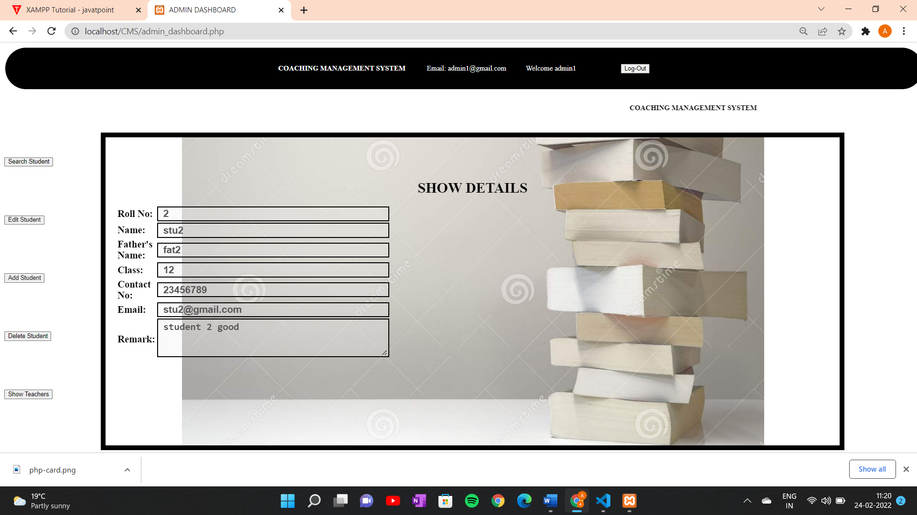

|  |  |  |  |
| --- | --- | --- | --- |
|  |  |  |  |
|  | **Edit Student** The admin can edit the details of the student by clicking edit student button and by entering the roll no of the student. | |  |
|  |  |  |  |

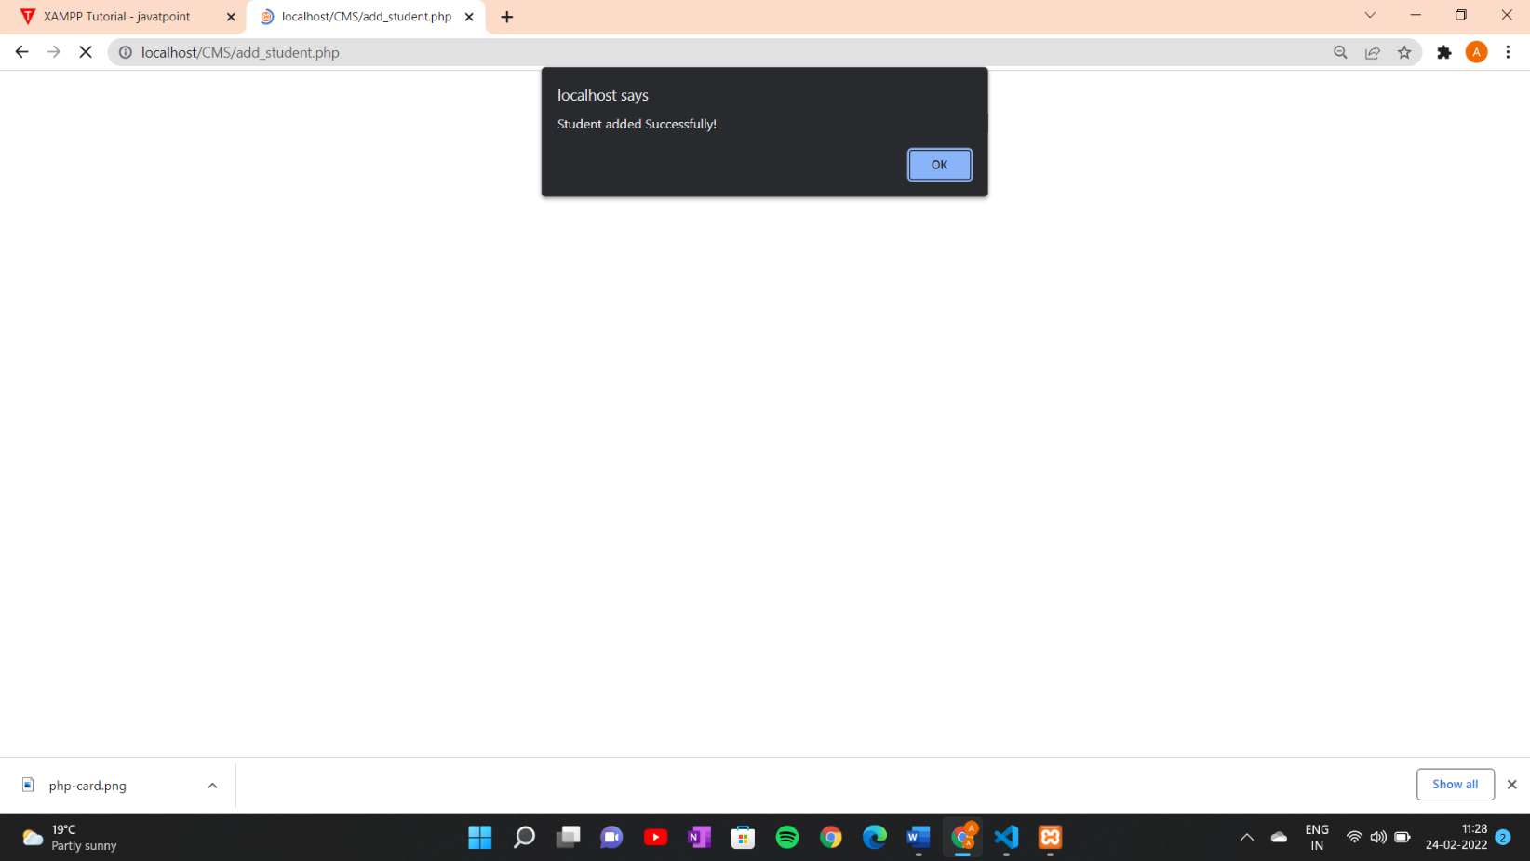

|  |  |  |  |
| --- | --- | --- | --- |
|  | **ADD Student** The admin can add the details of the student by clicking add student button.  A popup appears after the record has been added. | |  |
|  |  |  |  |

|  |  |  |  |
| --- | --- | --- | --- |
|  | **Delete Student** The admin can remove the record of the student by clicking delete student button.  A popup appears before the record has been removed to ask the confirmation from the admin. | |  |
|  |  |  |  |

|  |  |  |  |
| --- | --- | --- | --- |
|  | **Show Teachers** The details of the teachers can be fetched by clicking show teacher button. | |  |
|  |  |  |  |

|  |  |  |  |
| --- | --- | --- | --- |
|  | STUDENT MODULE: | |  |
|  | 1.After logging in to the student portal the student is redirected to student dashboard.  2.Search Student: With this button the student can see the details.  3.Edit Student: With this button the student can edit the details with limited fields. |  |  |

|  |  |  |  |
| --- | --- | --- | --- |
|  |  |  |  |
|  | Student Dashboard The student after logging in to the student portal can see the details and can also edit the details with limited fields to edit. | |  |
|  |  |  |  |

|  |  |  |  |
| --- | --- | --- | --- |
|  | **Show Student** The student can see the details by clicking show student button. | |  |
|  |  |  |  |

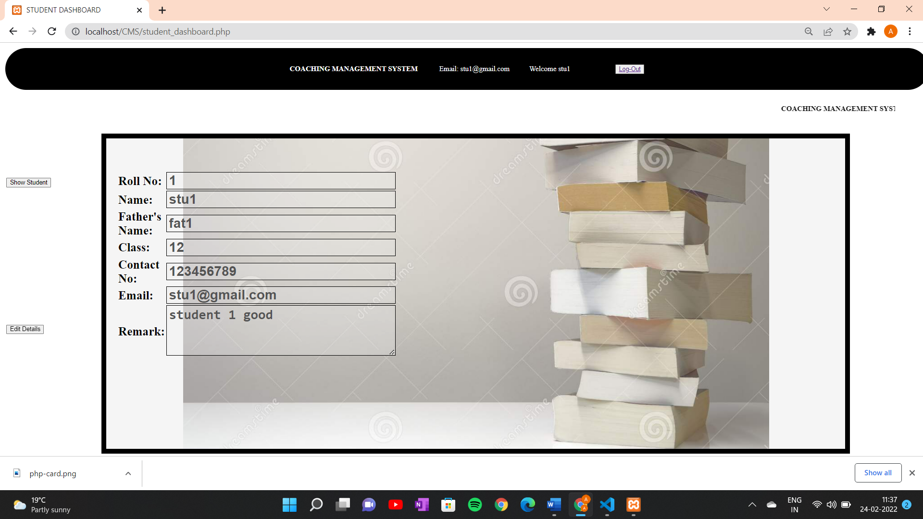

|  |  |  |  |
| --- | --- | --- | --- |
|  |  |  |  |
|  | **Edit Student** The student can edit the details of the student by clicking edit student button but with limited details can be edited. | |  |
|  |  |  |  |

|  |  |  |  |
| --- | --- | --- | --- |
|  | **Logout And Navbar** Both student and admin can end the session by clicking the logout button from the navbar.  The navbar contains the info of the name and email of the user. | |  |
|  |  |  |  |

|  |  |  |  |
| --- | --- | --- | --- |
|  |  |  |  |
|  | REFRENCES | **1.Code with Harry Web Development Course**  **2.Code with Harry php Back End Development Course**  **3.https://www.php.net/manual/en/extensions.php** |  |
|  |  | |  |